# Project Deployment & Management

# Project Deployment

**Project Deployment Link:** <https://github.com/repalakarthik/seGuRo_Drive>

**Project Video Link:** <http://www.youtube.com/watch?v=sYptma7AnHU>

# User Manual

Table of Contents

User Manual 1

Introduction 2

Scope and Purpose 2

Process and Workflows (How to use the System) 2

Work Flows 3

Process/Workflow1: Current Weather Subsystem 3

Process/Workflow2: Maps Sub System 4

Process/Workflow3: Check Fuel Subsystem 5

Process/Workflow4: Where is my Car Sub System 6

Sample User Interaction with the System 7

Check Current Weather 7

1) Login to App 7

Error Recognition 9

List of Known Errors/Bugs 9

# Introduction

## Scope and Purpose

SeGuRo Drive is a mobile web application to assist both mobile and web Users.

This User guide provides the purpose and the functionality of this Application and how to use four different features “Current Weather”, “Maps”, “Check Fuel”, and “Where is my Car”. It also covers assumptions about the users’ knowledge or experience.

## Process and Workflows (How to use the System)

This section Provides description of the overall process managed by the software, and how a user interacts with the system. It has different sub processes that user needs to navigate from one functionality to the other. See different workflows included after device constraints.

**Device Constraints:**

Mobile User need to have a smart phone or tablet to invoke this application.

**Smart Phones:**

Android Phones 4.0 or above

IOS phones 4.0 or above

**Design Choice:**

User need to know about default JQuery Mobile and HTML5 design layouts and it has a simple GUI to navigate user from one position to other.

# Work Flows

## Process/Workflow1: Current Weather Subsystem

## 

## Process/Workflow2: Maps Sub System

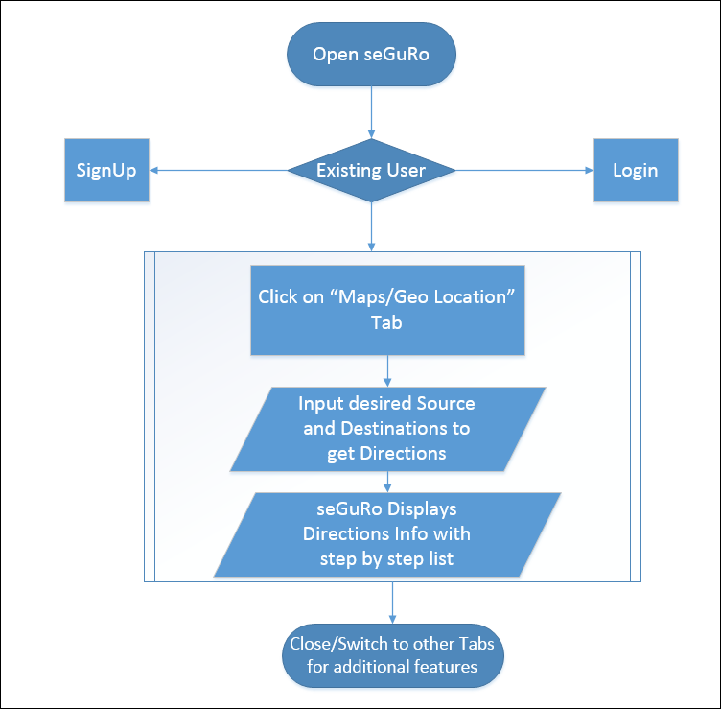

## Process/Workflow3: Check Fuel Subsystem

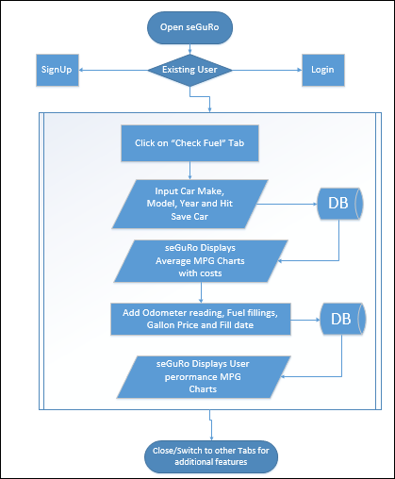

## Process/Workflow4: Where is my Car Sub System

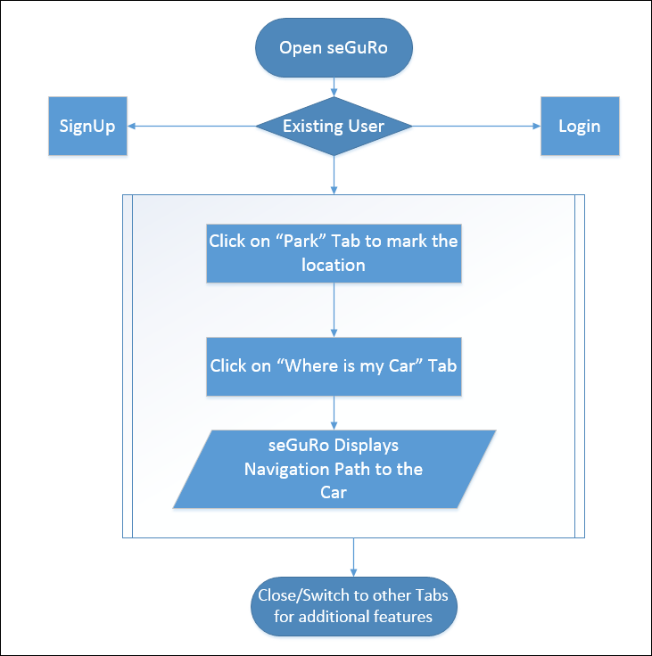

# Sample User Interaction with the System

## Check Current Weather

## 1) Login to App

## 

2) Click on "Current Weather" Tab

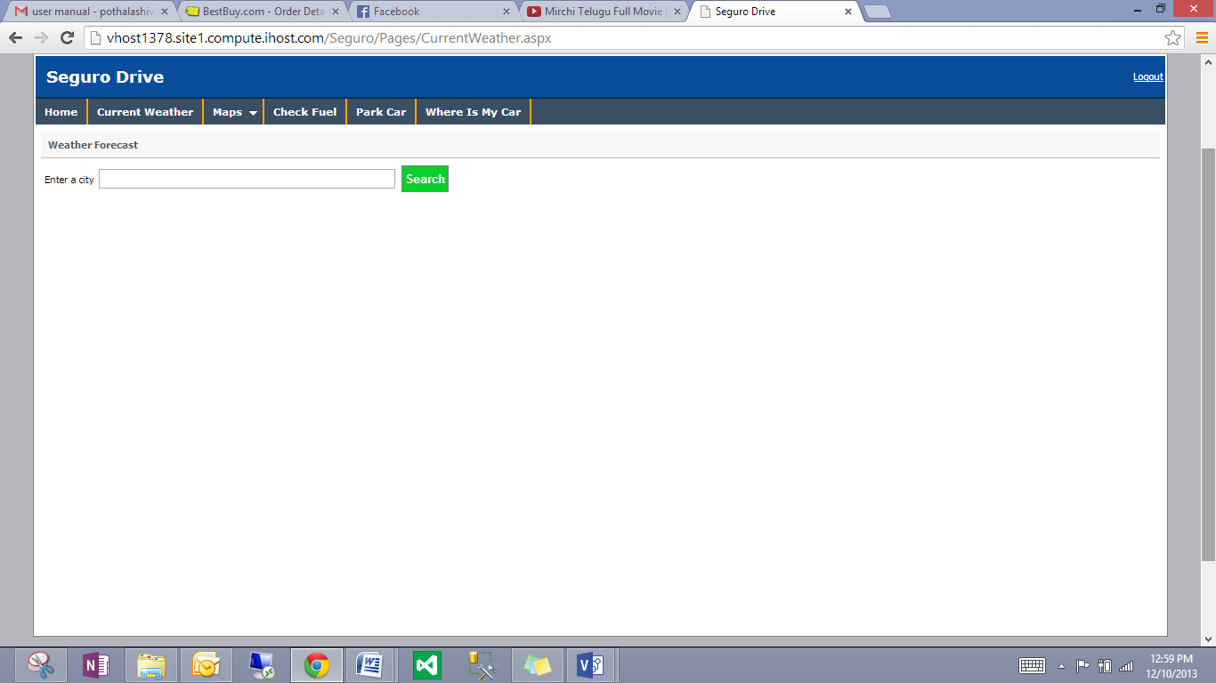

3) Input and select desired location

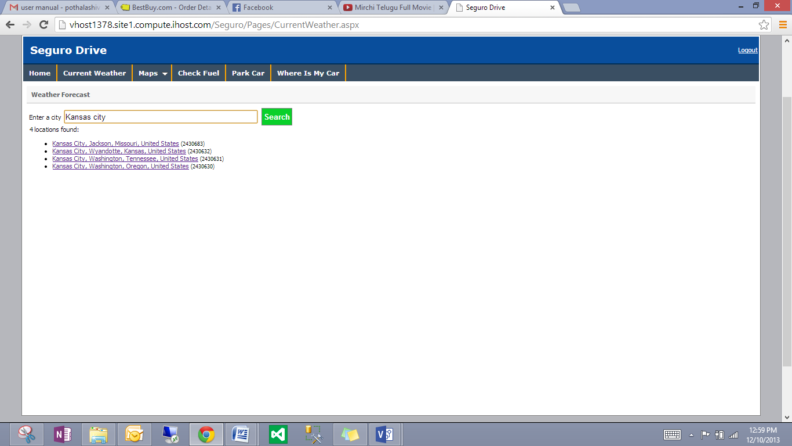

4) System Displays Weather info

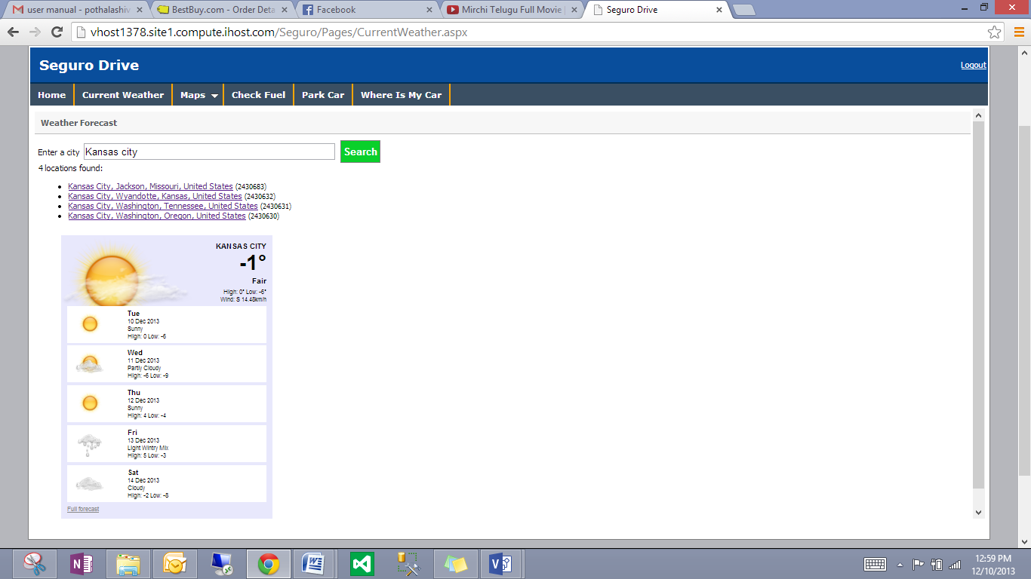

## Error Recognition

Error 404 - Server/Page not found

Session: User has to re-login if App is idle for more than 20 minutes.

**Note1:** Consider any logical errors related Average MPG data as estimated data provided by Make of the Vehicle.

**Note2:** See all differences in MPG performance changes are subjected to Vehicle condition as well.

## List of Known Errors/Bugs

Currently there are no bugs at all. There may be some bugs when code behind API’s go down or when Vehicle companies update with inappropriate MPG data.

# Project Management

**Project Management: Agile Process**

**Scrum Do:**

Scrum is an step by step agile software development framework designed for making the implementation of the software projects, products and applications easier. This mainly focus on "a flexible, holistic product development strategy where a team of developers would work as a unit to achieve a common task" which is contrast to a regular routine approach.

It also enables for the creation of self-organizing teams by encouraging co-location of all team members, and verbal communication among all team members and disciplines in the project.

**seGuRo Drive Project Scrum Do Link:**

<http://www.scrumdo.com/projects/project/seguro-drive/>

Screen shots of seGuRo Drive application in the Scrum Do website:

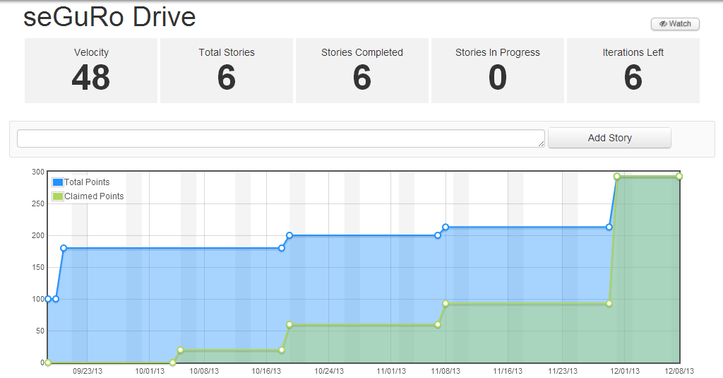

There are four increments named Increment 1, Increment 2, Increment 3 and Increment 4 planned as per the schedule and shows the time frame for each increment.

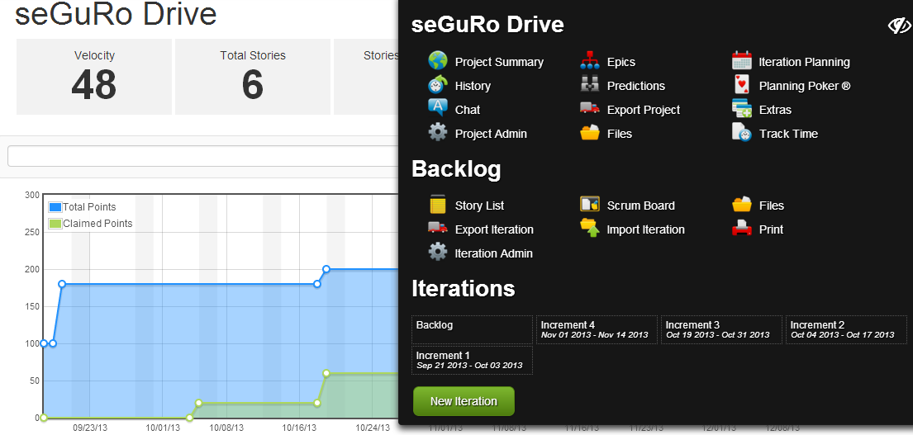

Each Increment is executed as per the schedule and contains the stories/tasks to be completed.

**Increment 1(**Sep 21, 2013 - Oct 03, 2013**):**

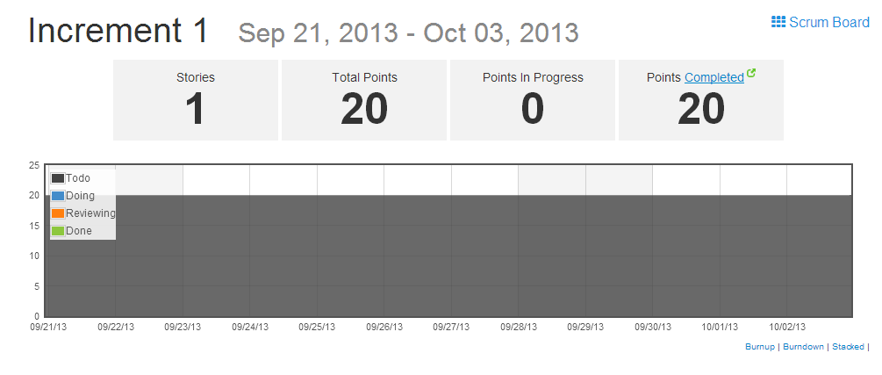

## Story: As a team we want to develop and test weather services so that it can be integrated with the seGuRo Drive App.

As the story is completed, the story has been changed from To-do, Reviewing and Doing state to the **Done** state.

Each story can be assigned to any person, it can be defined with points depending upon complexity, category, epic and Iteration.

In Iteration phase, the story can be assigned to any increment as per the requirement.

This is repeated for all the increments.

**Increment 2(Oct 04, 2013 - Oct 17, 2013):**

**Story**: As a team we want to develop and test Navigation services and Parking services so that it can be integrated with the seGuRo Drive App.

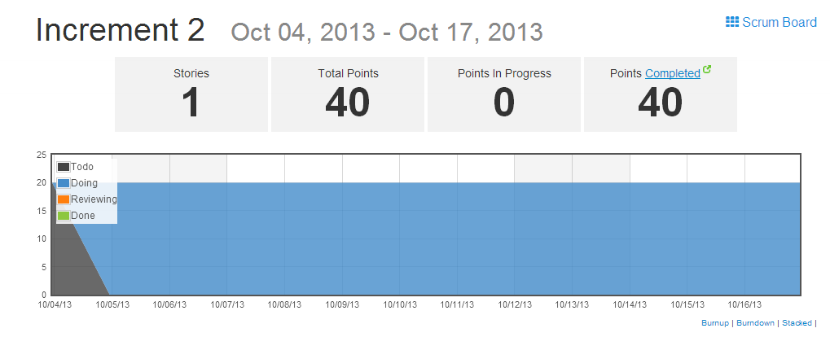

**Increment 3(Oct 19, 2013 - Oct 31, 2013):**

**Story**: As a team we want to create login and registration pages so that user can log in to the application.

**Story**: As a team we want to change the front end design so that it looks good with application.

The difference observed in Increment 3 from rest of two is that, this increment has two stories to process.

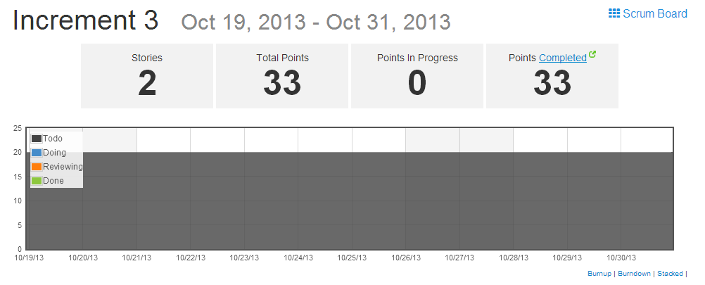

**Increment 4(Nov 1, 2013 - Nov 14, 2013):**

**Story:**  As a team we want to develop and test fuel monitor services so that it can be integrated with the seGuRo Drive App.

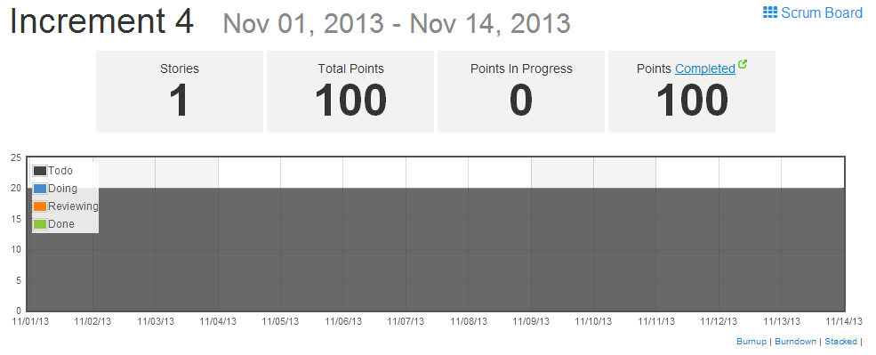

**Final Project Evaluation:**

* Discuss how well your project satisfies your original requirement specifications.

The project satisfies all the initial requirements mentioned in the proposal document.

* Were you satisfied with your design process?

Yes, the design process is well planned and organized so that it meets the real world project standards.

* How helpful was the agile process?

Agile process was helpful in planning the development of the entire project, tracking of the pending stories, estimating the

expected end date of project.

* How would you do the agile process next time?

We stick to the followed process and try to be more effective in terms of points calculation and categorization of stories next time.

* Did you stick to your project plan schedule?

Yes, we have planned as per the increments and followed it in the project development.

* What was the real management structure within your group?

Yes, there was an effective management procedure followed in the group where the work is shared in the form of layers with each layer having equal importance

in completing the project.

* Does it bear any resemblance to structure that you had planned?

Yes, it is similar to that of what he have planned.

* Did you have any problems getting each member to do his/her share of the work?

There are no issues with assigning tasks to the team member because of the Agile structure we followed.

* Do you have any suggestion on how this could have been handled better?

Agile process would be more effective if it would track the Service Level Agreement breaches of each task.

* Discuss what you might have done differently if this were a real world project? Any recommendations for next year?

If it would be a real world project, we would have changed the "Check My Fuel" service.

We initially planned to give the inputs of vehicle dynamically, but that required hardware device to be installed.

So, in real world/organization there is scope to install the hardware devices due to the cost planning.

**Project Members Evaluation:**

|  |  |  |  |
| --- | --- | --- | --- |
| Content | Member | Contribution | Total |
| Project Development (80%) | Karthik Repala | 34 | 100% |
| Sivakumar Pothala | 34 |
| Surendra Koripella | 32 |
| Final Submission (5%) | Karthik Repala | 34 | 100% |
| Sivakumar Pothala | 34 |
| Surendra Koripella | 32 |
| Video Production (8%) | Karthik Repala | 34 | 100% |
| Sivakumar Pothala | 34 |
| Surendra Koripella | 32 |
| Others (7%) | Karthik Repala | 34 | 100% |
| Sivakumar Pothala | 34 |
| Surendra Koripella | 32 |
| Overall Contribution | Karthik Repala | 34 | 100% |
| Sivakumar Pothala | 34 |
| Surendra Koripella | 32 |